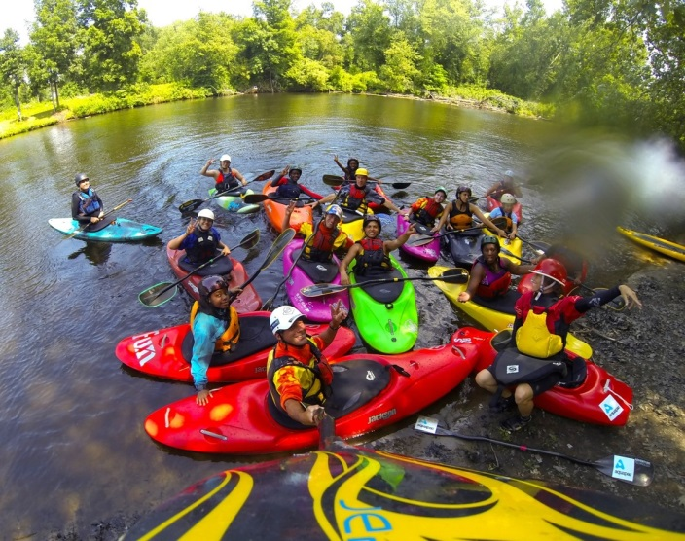
Applying Social Learning Theory
- Make a list of between 8-12 key words associated with Bandura’s Social learning and Social Cognitive Theories of Learning.
- Read the following story and highlight any sections which link to SLT; discuss in pairs
- Write a paragraph, using as much correct terminology as possible, to explain how Toby learns how to do the eskimo roll
- Write an ending for the story about Ben where things do not go quite as they did for Toby.
- Explain why Ben may not complete the eskimo roll successfully first time, use as much terminology from social learning theory as possible, as you did before
- Change elements of the story to make it more likely that Ben will complete the roll successfully, be as creative as you like, you can change, what happens before, the type of family they are from, the boys relationship with each, what is said and done, you can introduce new characters etc, etc.
Ben (13) and his brother Toby, (15), are on an adventure holiday. As part of the programme of activities, they have gone kayaking. Before the holiday, the brothers watched lots of you-tube videos of kids white-water kayaking. It looked so exciting; Toby hoped that one day he would go to Canada and try for himself. The boys’ mum wants them to gain confidence and skills so that they can go kayaking as a family, next year in France.
The instructor, Lola looks about 19. She is a very pretty and friendly. As part of the induction, she has to teach them what to do if they capsize. It’s called an “eskimo roll”.
Although Ben is a reasonably good swimmer, the idea of being underwater whilst stuck in the boat makes him anxious. He starts to sweat as he watches Lola showing the boys where to hold the paddle and how to position their hands.
Toby watches Lola carefully, although it’s easy to get distracted from what she is saying though, her wet suit doesn’t leave much to the imagination…Toby is tall and strong despite his age and is keen to show what he can do.
He manages the roll perfectly first time, Lola gives him a massive smile, and says “you’re a natural Toby!” Ben looks on nervously…

