Bandura (1965)
Aim: This study aimed to reveal whether levels of aggression in children exposed to aggressive role models is mediated by the consequences of the aggressive for the models and also whether offering incentives for imitating the observed aggression also impacts the levels of aggression observed in the children regardless of whether aggression was rewarded for the model.


What was the IV? Use the TV screens below to draw and label a sketch to indicate the ending of the film for each of the three levels of the IV. You can cut these out and stick them into your red book with the rest of your notes.

What was the DV: physical and verbal imitative aggression; how was this different to the two other studies?
Similarities:
- Both 1963 and 1965 were interested in whether children observed aggression they had observed on screen/film
- All three studies use children of a similar age 3-6 years (mean 51 months) from Stanford University Nursery School
- Like the 1961 study, 65 uses random allocation of children to the experimental groups to overcome participant variables and increase internal validity.
- Like the previous study a female experimenter is used

Differences:
- The 1965 study was concerned particularly with what happened to the model once they had enacted the aggressive acts; thus the IV was the consequences of aggressive behaviour for the model and there were three levels, what were they? (3)

- The 65 study has less children than either of the 61 or 63 studies as there are only …………. male and ………….. females children giving a total of ……………. in comparison with 72 and 96 in the other two studies (3)

- Unlike the other studies there is no female aggressive model in this study, and there are ………….. male models not one, (1)

- The aggressive acts shown towards Bobo were very similar to the other two studies except there was one new behaviour which had not been used before; what was it? (1)

- The film clip was only 5 minutes long in the 1965 study compared with ………… minutes in the 1963 study.

- There were some different verbalisations modelled that had not been heard in the previous studies, what were they? (2)

- No mild aggression phase

- Experimenter not in room whole time

- Less time in testing room 10 mins

- 5 second intervals

- One way mirror

- Observation schedule

- Irr for all children

- Irr established for 10 children perfect match almost aaas no subj interpretation required

- Once the children had been observed once the female experimenter came back with some treats for the children which would become positive incentives for recreating physical and verbal acts that they had seen. Draw pictures and labels them to show the types of treats that Bandura used:


Complete the speech bubble to show what the experimenter said to children in this final phase of the observation. You can also cut this out and stick into your book:



Findings: Bandura presents this easy to read bar chart of his findings, describe what can be seen in the graph (4) Agin you can stick this in your book.
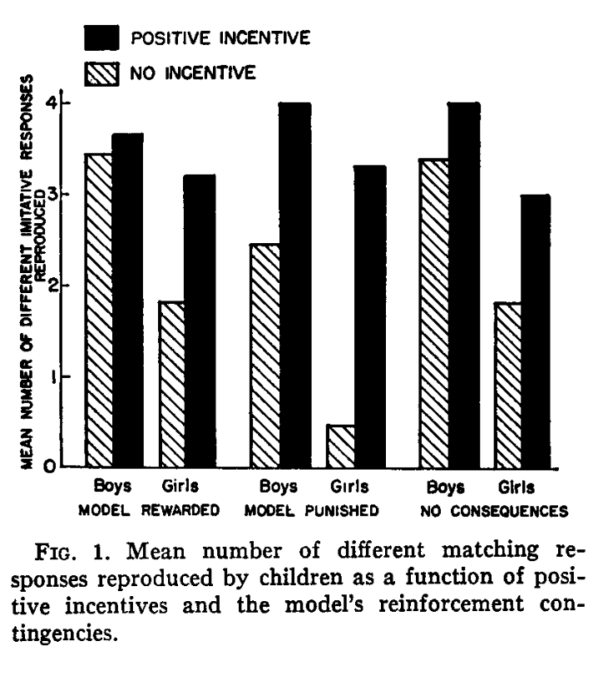

Bandura concluded that while vicarious reinforcement and punishment affected the performance on the actions in the first instance, when the children were rewarded for demonstrating imitative aggression, many more acts were seen, showing that the vicarious punishment for example did not stop the children learning the act (retention) is merely stopped them from repeating it in the first instance (motivation). Once they were motived by the positive incentives they were able to demonstrate a range of imitative aggressive behaviours both physical and verbal.

Bandura also found some evidence for reproduction being an important mediating process in imitative learning as the pre-schoolers imitated more of the motor responses (67%) than the verbal responses (20%) which they may have found more challenging.
The fact that positive incentives elicited more aggressive behaviours from the girls shows that identification with same sex model may not be a necessary condition for learning, they clearly had learnt the behaviour just did not repeat them without the positive incentives demonstrating that it was “okay” to do so
Boys were more easily disinhibited than girls as they showed more agg when the model was rewarded than the girls who presumably had been exposed to reinforcement histories that suggested aggressive modelled or otherwise would be punished.
No consequecne seemed as effective as a positive consequence in bringing about aggression, the disinhibitng effect, e.g. when something is not punished it is learnt and performed.

