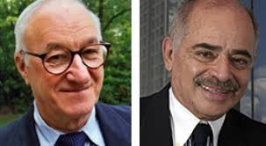
Evaluating a theory: Applications and Contribution to Society
Figure 1: Albert Bandura and Miguel Sabido
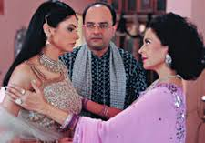
One way to evaluate a theory is to look at the practical applications of that theory to real life. Albert Bandura has arguably made a truly astonishing contribution at a global level as you see from these articles. This was recognised when US President Barack Obama named Bandura as one of nine recipients of the 2015 National Medals of Science, the nation's highest honor for achievement and leadership in advancing science.
Use the articles to help you answer the questions below. Make sure that your answers are specific in their use of example. This activity will help you when writing essay that evaluate Social Learning Theory but also when you are addressing Issues and Debates questions in Paper 3.
- What is the Sabido Technique?
- What is a telenovela?
- Describe three examples of social problems that have been addressed through telenovelas in three different areas of the world.
- What evidence is there that the telenovelas have brought about positive change in these countries? Try to find some qualitative evidence as well as some quantitative.
- What does Bandura say to those who have asked “who has the authority to dictate what is “right” in these different cultures?”
- Explain how the telenovelas achieve their aims using as much terminology from social learning theory as possible.
Extension Tasks
- Choose an issue which you perceive to be local, national or international social or environmental problem today; devise a brief plot line and set of characters for a telenovela to address this. Use the article to think about the characters and their motives. How would you ensure that the story has the greatest impact and desirable behaviours are most likely to be enacted; provide a brief rationale for your plot line where you integrate as much social learning theory terminology as you can. Why not create a trailer for your new telenovela using iMovie on your iPad
- Imagine you are being interviewed by Channel 4 news about this new telenovela; how will explain the plot and the theory behind it. Why not role play the interview – send it to me and I can upload to our YouTube channel.

