Act on behalf of someone else: | 
If someone is perceived to have this, we will follow their orders: | 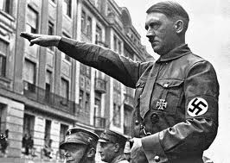
We take responsibility for our actions and follow our own beliefs about right and wrong | 
Process by which we acquire an understanding of what is socially acceptable | 
Process described by Darwin which explains how animals become adapted to their surroundings gradually over many generations | 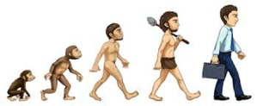
State of discomfort that arises when we follow orders and in doing so go against what we believe to be morally right or socially acceptable | 
A defence ………….. is a short term coping strategy (or way of escaping!) from anxiety or inner conflict | 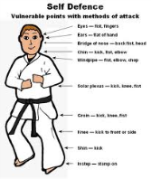
Cognitive …………… occurs when we hold two beliefs that conflict with each other, i.e.”harming others is wrong” and “I harmed another person”; we cannot change what we have already done but we can change how we think about it; “harming him was fine because I had no choice and I was not responsible” | 
Our tendency to obey allows us to follow social rules which helps us to create social ………………… which is necessary to live successfully as a group | 
A defence mechanism that involves not accepting or actively rejecting at you have done and saying it didn’t happen | 

