


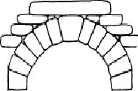

Evaluate/Assess a THERAPY: EPEC
AO1 Features of therapy to be embedded into the essay (think! thorough and accurate) | Create a chain focusing on….(think well developed and coherent, slow down and proof read!) | Inject a “competing argument” (follow it through, grasp the significance!)
1 | Supporting evidence: (think sandwich model, think links!) | Weakness of the evidence:
2 | Conflicting evidence (think sandwich model, think links!) | Weakness of the evidence:
3 | Practical issue - good or bad, (think sandwich model, think links!) | On the other had (try comparing with another therapy)
4 | Ethical issue - good or bad, (think sandwich model, think links!) | On the other had (try comparing with another therapy)
Balanced conclusion: |   Think, balanced and nuanced
ATCHOO (BC)

