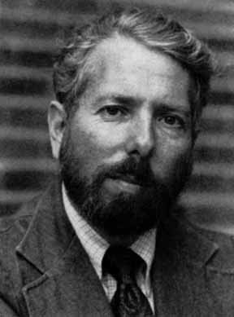
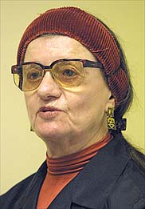

David Mandel (1998)

Diana Baumrind (1968)
Orne and Holland (1968)
I conclude that…

