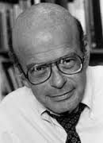
Tip: Try to use the following words: Medical model, anti-psychiatry movement, validity, DSM, You should also look up the following people who influenced Rosenhan’s work: Thomas Szasz and RD Laing.

Writing a detailed aim…
It’s 1973 and David Rosenhan is being interviewed for a radio programme about the state of psychiatry today following the publication of his iconic study.
The interviewer has just asked him…
“So David, can you explain to our listeners what it was exactly that you were aiming to find out in your study?”
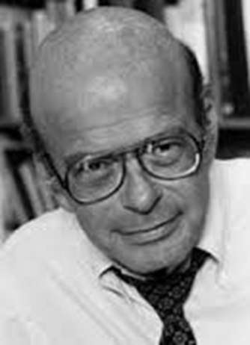

Interviewer: Well David, looking back at your original aims, what possible conclusions were you able to make in the light of your experiences and those of your fellow pseudo-patients?

TIP: Consider mentioning type 1 and type 2 errors, remembering that Rosenhan uses these phrases the opposite way round to everyone else! He calls a false positive (i.e. calling healthy people sick) Type 2, and a false negative calling sick people healthy Type 1. Remember to explain why he thinks it’s so bad that psychiatrists, in his opinion, make so many “Type 2” errors.
Writing a detailed conclusion…

