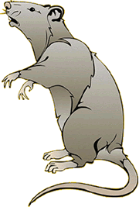

ANIMAL RESEARCH: Is it necessary in psychology?

The have very clear guidelines about the use of animals in psychological research and as their use in therapy. These guidelines adhere to the 1986 Animals (Scientific Procedures) Act and the Home Office regulations for the use of animals. Any psychologist who wishes to carry out research using animals must apply to the Home Office for a Project Licence, they must also apply for Personal Licences for anyone who is involved in carrying out the research.
Use the BPS “Guidelines for Psychologists working with Animals” to answer the following questions
a) What are the “Three R’s” (Russel & Burch, 1959) that researchers must consider when working with animals?
b) What do researchers need to consider when choosing the type of animal to be used in the research?
c) What scientific procedures are covered by the 1986 act?
d) Describe the difference between a PROJECT LICENCE and a PERSONAL LICENCE.
e) When applying for a licence researchers have to discuss their justification for the use of animals with a Local Ethical Review Committee. List the factors that need to be considered when making a “cost-benefit analysis”
f) What responsibilites do researchers have towards their animals whilst they are not being studied (but still captive)
DO YOU THINK IT IS RIGHT TO USE ANIMALS FOR PSYCHOLOGICAL EXPERIMENTS?
ARE THERE ANY CIRCUMSTANCES WHEN THERE IS NO OTHER CHOICE TO USE ANIMALS?
COULD YOU MAKE A BALANCED JUDGEMENT IF YOU WERE ON THE ANIMAL ETHICS COMMITEE?


Dr Mole is planning to carry out an experiment to find out more about addicitve behaviours. He has decided it would be unethical to use people so he has is going to use rats instead. He has submitted the following plan to the BPS Ethics Committee and the Animal Procedures Committee of the Home office.
RESEARCH QUESTION: Are there “pleasure centres” in the brain that could be linked to addiction?

PROPOSAL: I intend to insert an electrode into the brains of 100 rats. This will lie near or in the hypothalamus. The rat will then be placed in an observation cage and allowed to explore. Whenever the rat investigates and presses on a particular lever an electrical current will be passed into to the brain causing stimulation of that area.
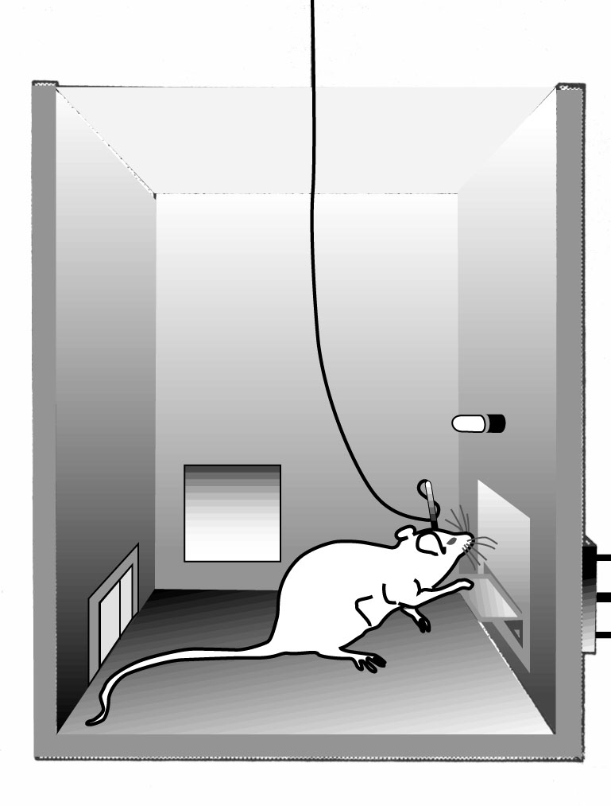

The electrode will remain in the brain at all times, the rats will be placed in the box for 2 hours every day for 14 days. Observations will be made of how long it will take the rat to find the lever each time, the effect on the rats behaviour when the brain is stimulated and the number of times the rat presses the lever on each trial.

YOUR TASK: You are a new member of the Animal Procedures Commitee and this is the first application you have been asked to review. You will need to make a decision about whether Dr Mole’s research should go ahead. You need to read his proposal and come to a BALANCED DECISION whether you give him permission to carry out his research.
Things to consider:
Could Dr Mole carry out this research without using animals?
Is this research JUSTIFIABLE (Will it add anything to our knowledge of human behaviour? Does it put the rats under undue stress? Do the benefits out weigh the costs to the rats?)
Are there any changes you would expect Dr Mole to make before you give him permission to carry out the research?
YOU WILL BE DEBATING THIS PROPOSAL ON
........................................

