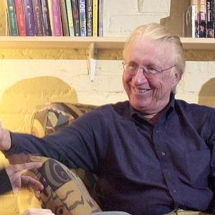
Describing …
Social Impact Theory (Latane, 1981, 1996)

Although, we are looking at how this theory helps us to explain obedience to authority, it is actually a theory of ‘social influence’ in general. This means it can be helpful in predicting people’s behaviour in lots of different situations and people have used Latane’s theory to help explain crowd behaviour, bystander intervention and conformity as well as obedience.
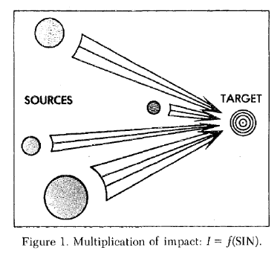
Social Impact is a pretty broad term. It refers to “the great variety of changes in physiological states and subjective feelings, motives and emotions, cognitions, beliefs, values and behaviour that occur in an individual; human or animal, as a result of real, imagined presence or actions of other individuals”

How are we affected/impacted by others?

Persuaded
Inhibited
Supported
Threatened

Latane likens social forces to physcial forces like light , gravity, sound and magentism all operating in a social forcefield or social strcuture.


Latane calls the people doing the impacting… THE SOURCE.
He calls the person being impacted…THE TARGET.

The source can affect the way the target feels, thinks and behaves.
Latane believes that we can predict how much the target will change his or her thoughts feelings and actions by measuring three factors which each relate to the source.

FACTORS | What does he mean by that?
Strength | How important the group of people are to you; their ‘salience’, power, authority, intensity. Their importance is likely to be determined by such things as socio-economic status, age, prior relationship with, future power over you etc.
Immediacy | How close the group is to you in time and space at the time of impact, the absence of intervening barriers/buffers or obstacles; this relates to the proximity of the source to the target
Number | The source could be just one person but Latane argues the number of people people in “the source” group can affect the amount of impact on the target

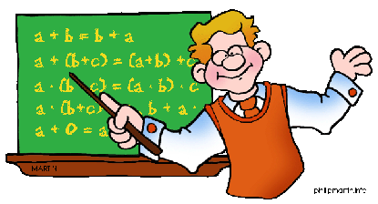
Latane constructed a mathematical model to explain how these three factors interact. This model has successfully predicted the results of many studies of majority influence and minority influence. He says that Strength (S), Immediacy (I) and Number (N) have…
“a multiplicative effect”
Meaning that S x I x N = Social impact

Latane uses the analogy of a lightbulb to explain his idea further; if you have a bulb of a certain ‘strength’, say 100 watts and place it 20 feet from a wall, it will cast light on the wall of a certain intensity (influence). If you move the bulb closer to the wall (immediacy) the intensity increases. If you move it further away it decreases. Changing the wattage of the bulb will also affect the intensity of the light on the wall as would adding second or third bulbs.


Latane makes a specific point about number, he says that once the source group is bigger than three, each additional person has less of an influencing effect, so the difference of one extra person in a group that goes from two to three people is larger than the difference of adding an extra person to a group of 52 to make 53. In economics this is called “The Law of Diminishing Returns”. The first pound you earn has more impact than the 100th. By this reasoning, the difference between 0 and 1 is greater than the difference between 99 and 100. Latane isn’t saying that a group of 100 would be less powerful than a group of 3 but simply that the difference between the 99th and 100th person is less than the difference between the 2nd and 3rd.

Think! How would you measure strength, immediacy and number?
- Think about how we would quantify (give a number to) STRENGTH (the importance of the source to the target)?
- What problems might arise when we try to decide this?
- How would we measure IMMEDIACY?
- How might the units used differ to the units used to measure STRENGTH?
- Okay so NUMBER is pretty straight forward…is this type of data similar or different to STRENGTH and IMMEDIACY?
- How do the answers to these questions relate to the key terms objective and subjective.
Methods Alert! Soon you will be able to use the terms levels of measurement and nominal, ordinal and interval to elaborate your answers to these questions.

Applying the theory to real life situations

In his 1981 paper, Latane gives many examples of how his theory predicts every day occurences. There are a couple of interesting examples of how impact decreases with increasing numbers.
- Leaving a tip: Latane asked a group of waiters to record the number of people in each group of diners, how much the bill was and how much tip they left. He found that the bigger the group the less tip they left per head; individual diners left around 19% of their bill but groups of 5-6 left less than 13%.
- Describe the study by Berkowitz et al (1969):

The Divisional Effect
So far we have only considered the effect of one or several sources on a single target but what happens when there are many targets to be influenced by just one source?
Can you think of any examples of social situations of this nature?

Latane says that sometimes the impact of a single source is divided by the number of targets and therefore becomes less potent. This idea has been tested in the field of bystander intervention which you can read more about if you are interested. However here is has been found that there is something of a “diffusion of responsibility” whereby lone bystanders are more likely to give help to an apparently needy confederate than people in groups, (Latané and Darley, 1970).
Latane’s (1981) evaluative comments on his theory:
- the theory is rather generalised and it does not explain how changes are brought about but it does make very specific testable predictions of the magnitude of change based on specific features of the target/source interaction
- difficulties can arise as the accuracy of the estimation of course depends upon the way in which the data has been quantitifed regarding strength and immediacy which are not necessarily measured in standardised units (ratio level of data)
- it is not meant as a substitute for any other theory that explains how and why these forces bring about changes
- it provides general, overall set of rules that seem to govern social impact and is useful in reducting behaviour in a wide range of everday social situations
- the theory views individuals as relatively passive with regard to the way in which they are impacted by others’ behaviour towards them and would predict similar outcomes for any one exposed to a source of the same strength, immediacy and number
- some people may be more resistant to social impact and some more passive; some people are more likely to end up as a source than a target
- Although ‘social situations’ elicit behaviour from individuals; individuals end up in certain situations due to individual differences and characteristics relating to them as a person; reciprocal determinisms (Bandura)
- Social impact theory emphasises the impact of sources on targets and forgets that sources are altered by targets too; i.e. social interaction is reciprocal and bi-directional; for this reason it is known as a static model not a dynamic model.
- When the two football teams meet and violence erupts it would be hard to predict outcomes if strength, immediacy and number were similar.
- Latane himself also notes that as the theory stands, it does not explain the longer term outcomes of social impact might build over time, from acute to chronic.
- The theory makes suggestions about how people might wish to proceed in everyday situations to ensure greatest impact; Latane calls this “social engineering”,i.e. setting up social situations (manipulating); please use the activity to complete to help you think of examples to elaborate this criticism in assessed work.

