Explain how biological factors may affect one cognitive process

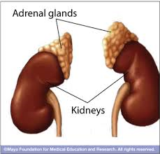
Psychologist who explained the links between emotion and memory: …………………………

He explains how hormones associated bodily arousal, which the Canon-Bard Theory says is similar for a wide range of emotion, can alter the way certain areas of the brain work, resulting in memories of differing quality.
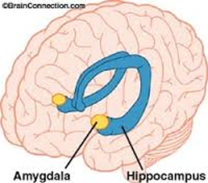
McGaugh says that when we are suddenly scared by something our body responds by releasing two hormones: …………………………… and ………………………………………. from the …………………………………… which are situated on top of the ……………………

These hormones influence various areas of the brain, including the ……………………….. an important centre for processing emotional stimuli.


This region is in communication with other areas where memory creation occurs including the …………………………
If the amygdala is activated and a memory is in the process of occurring, a stronger memory is made. McGaugh calls this “emotional memory” and it is this process that can account for so-called ‘………………………………………………………’
The brain has evolved a way to make sure we remember emotionally arousing experiences because this ability has …………………………… value, creatures that are able to remember the situations which are life –threatening and act on these memories, are more likely to survive than those that don’t!

This said, McGaugh has explained that the process does not differentiate between positive and negative emotions, (probably because as Canon-Bard explains, they are all pretty similar at a biological level, it is cognitive appraisal that makes them ‘feel’ different’) - he says any emotional experience can leave an “…………………….. impression on the mind”.
There is no survival value in remembering trivial experiences and so they are forgotten as they do not trigger the release of hormones such as adrenaline which enhance the memory trace. McGaugh also explains that over time, a stronger and more lasting memory is created and he calls this process “memory c…………………………..”.
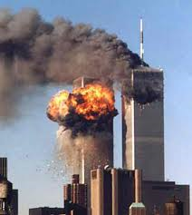
Sharot and Phelps (2006)

Pps:

When was this conducted:

They were asked their proximity from the towers: D…………….. or M…………………
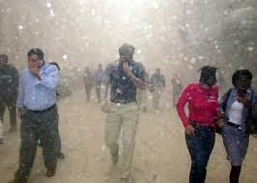
Used what sort of brain scanner:

Projected what words:

Why:

Examined activity in which brain regions;

Pps asked to rate their memories for:

Findings: Sketch two scattergrams to illustrate the main findings and write the correlation coefficients next to them. The axes will be….
- proximity for the twin towers and activity in the posterior parahippocampal cortex
- proximity for the twin towers and activity in the amygdala

People who were in downtown Manhattan, near the World Trade Center, exhibited selective activation of the amygdala as they recalled events from 9/11, but not while they recalled control events from the preceding summer.

They also reported more vivid recollections of the attacks, including specific details about sounds and smells, than people who were a few miles away, in midtown, and experienced the event via television or the Internet. This was not the case for the Midtown participants.

The results suggest that close personal experience may be critical in engaging the neural mechanisms that underlie the emotional modulation of memory and thus in producing the vivid recollections to which the term flashbulb memory is often applied.


McGaugh and Cahill
McGaugh and Cahill have also conducted various experiments to demonstrate the role of emotion in memory.
Two groups of participants were shown a series of 12 images, each accompanied by a single sentence of narration.
IV:
DV:
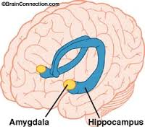
Findings: Sketch a bar chart to illustrate the findings.

Conclusion: the more activate the amygdala at the time the memory is encoded, the better the recall will be for this information.”

McGaugh then went onto complete a very interesting study looking at what happens if you are able to stop the activation of the amygdala during emotionally arousing events by decreasing levels of adrenaline.

IV:
DV:

Findings: Sketch the results on a bar chart.

“They remembered a lot of what they saw, but they didn’t have a selectively stronger memory for the emotional content”. McGaugh concluded that taking drugs such as these during memory consolidation, i.e. after traumatic events could possibly help to minimise symptoms of post-traumatic stress disorder, which include intense, vivid and intrusive flashbacks or nightmares of the traumatic events, accompanied by extreme anxiety.

What are your thoughts on the ethics of using such drugs?

Post-Traumatic Stress Disorder
What are the symptoms?

What are the causes?

How could drugs help sufferers and what impact would this have on society?

Pitman (2002)
What did he do?
IV:

DV:

Findings: Sketch the results

Is the study reliable?

What are the problems with this study?

Cortisol can also impair memory
Cortisol belongs to a family of stress hormones called G…………………………….. and these can interfere with the energy supply to certain brain cells involved in memory.
This what happens if we are stressed out when we are trying to remember something and this is different to the effects of stress when we encoding new emotional memories.

Newcomber et al (1999)
Pps: 25 men and 26 women between ages 18 and 30
IV:
Group 1 - ………………… dose cortisol capsules ……………. daily for …………….. days (similar to the stress of ………………………………….)
Group 2 - ………………..dose cortisol capsules ……………..daily for …………….. days (similar to the stress of …………………………………………………………………………..)
Group 3 - ……………………………………………….
They examine effects of the cortisol before taking, after 1 day, after 4 days of capsules and then after ……………………. days of ceasing capsules
DV: listen to and recall parts of a paragraph to assess ………………………………. memory; involves several brain regions, including the hippocampus
Findings: 14/15 individuals taking the high dose experienced a decrease in memory performance after four days of treatment. No effects were found on the other cognitive tests.
"We saw memory impairment only in the individuals treated with the higher dose and only after four days of exposure. The good news is it appears that it would take several days of stresses like major surgery or severe psychological trauma in order for cortisol to produce memory impairment. And after a one-week wash-out period, memory performance returned to the untreated levels."
The cortisol levels were high in this study but Newcomber believes there may be some effects from long-term exposure to slightly lower levels
Newcomer does not believe the memory effects demonstrated in this study are part of any process associated with loss of neurons or permanent damage in the hippocampus or other brain structures.
"The evidence suggests that these kinds of cortisol levels are not neurotoxic themselves, perhaps sustained, high levels make neurons vulnerable to other types of injury, but we don't believe the memory impairments we saw in this study are in any way associated with an irreversible process. In fact, our evidence shows that this memory impairment is quickly reversible."

McGaugh explains how cortisol impairs memory
- Stressful situation - ………………………….. immediately release ……………………, and then ……………………… if the threat is still severe after a few minutes.
- cortisol increases levels of ………………………….. and stores of glycogen in the …………………………..; it remains in the brain much longer than adrenalin and adversely affect brain cells over time
- cortisol interferes with the function of ………………………………….. – chemicals which brain cells use to relay signals between each other.
- Excessive quantities of cortisol make it harder for the brain to process information and retrieve data from ……………………. because cortisol diverts large amounts of blood glucose to the ………………………., and away from the …………………………
- This results in an ………………………… shortage in the hippocampus, compromising its ability to access or create memories

