A Level Psychology
Issues and Debates
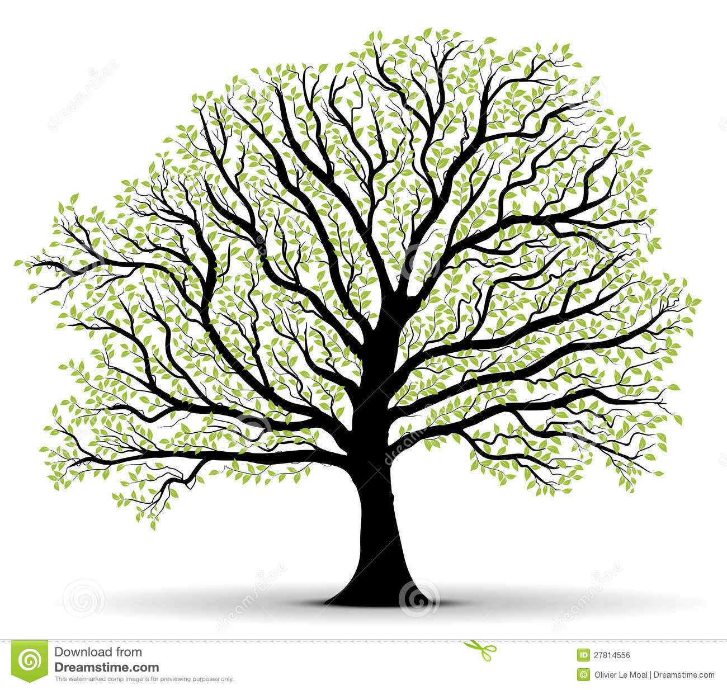
Work Book

Contents
A level psychology students are required to critically consider a wide range of issues and debates that weave their way through every topic in psychology. In Paper 1, Section E you will be required to answer two extended response questions, on issues and debates and therefore you will need to pay careful attention to these as they arise naturally within our teaching. The questions are likely to be worth 8 and 12 marks. However there is no rule that says the questions have to be split in this way. We will also revisit all of the issues and debates towards the end of Year 13
Here is the full list of issues and debates that you need to be able to write about:
- Ethics
- Practical issues in the design and implementation of research
- Reductionism
- Comparisons between ways of explaining behaviour using different themes
- Psychology as a science
- Culture and gender
- Nature/Nurture Debate
- Understanding how psychological knowledge has developed over time
- Issues of social control
- The use of psychological knowledge in society
- Issues relating to socially sensitive research

Ethics
Key AO1 for this Issue/Debate | Studies to use as examples | Theories to be used as examples

Practical issues in the design and implementation of research
Key AO1 for this Issue/Debate | Studies to use as examples

Reductionism
Key AO1 for this Issue/Debate | Studies to use as examples | Theories to be used as examples

Comparisons between ways of explaining behaviour using different themes
 | Key concepts | Evaluation
Biological |  | For:  Against:
Learning |  | For:  Against:
Social |  | For:  Against:
Cognitive |  | For:  Against:

Psychology as a Science
Key Concepts | Elaboration | Links to studies/Theories
Hypothetico-deductive approach

Falsifiability

Replicability (standardised procedure)

Quantitative data

Objectivity/empiricism

Manipulation of IV whilst measuring DV (eliminate confounding variables) thus increasing internal validity (reductionism)

Culture and Gender
Key AO1 for this Issue/Debate | Studies to use as examples | Theories to be used as examples
Ethnocentrism

Androcentrism

Alpha bias

Beta bias

Etic

Emic

Nature/Nurture Debate
Situational versus dispositional explanations for behaviour, e.g. does destructive behaviour result from immediate situation (nurture) as Mischel etc would have us believe or does it result from individuals differences which can be linked to culture/gender socialisation and upbringing (nurture) or underlying genetic predispositions towards certain personality traits (nature), chemical imbalances leading to aggression which is vented following frustration, etc.
Key AO1 for this Issue/Debate | Elaboration | Studies/Theories to be used as examples
Nature

Nurture

Diathesis-Stress Model

Epigenetics

Neuroplasticity

MZ/DZ Twin Studies

Cross cultural studies

Understanding how psychological knowledge has developed over time
Topic Area | Early Research | Contemporary Research
Social
Cognitive
Biological
Learning
Clinical

Issues of social control
Topic Area | AO1 | AO3
Social | Latane and social engineering
Cognitive | Intelligence testing (Lewis Terman)
Biological | Eugenics as noted above
Learning | Classical conditioning: Aversion therapy and conversion therapy, operant conditioning, Skinner’s novel “Walden Two”
Clinical

The use of psychological knowledge in society
Topic Area | AO1 | AO3
Social

Cognitive

Biological

Learning

Clinical

Issues relating to socially sensitive research
Studies in which there are potential social consequences or implications either directly for participants or for the class of individuals represented in the research, (Sieber and Stanley, 1988)
People that can be affected by SSR other than Pps:
- Families , friends of Pps
- Groups (religious, ethnic) that the Pps belong to
- Researchers
- Research institutions where the research was conducted

Topic Area | AO1 | AO3
Social

Cognitive

Biological

Learning

Clinical

