Exam Practice Questions
Measures of Dispersion

- Give two measure of dispersion (2)
- What is meant by measures of dispersion (1)
- What is meant by standard deviation (2)
Amy completed a questionnaire about people’s attitudes towards the homeless in China and the Czech Republic. Here are her findings from one of the questions she asked.

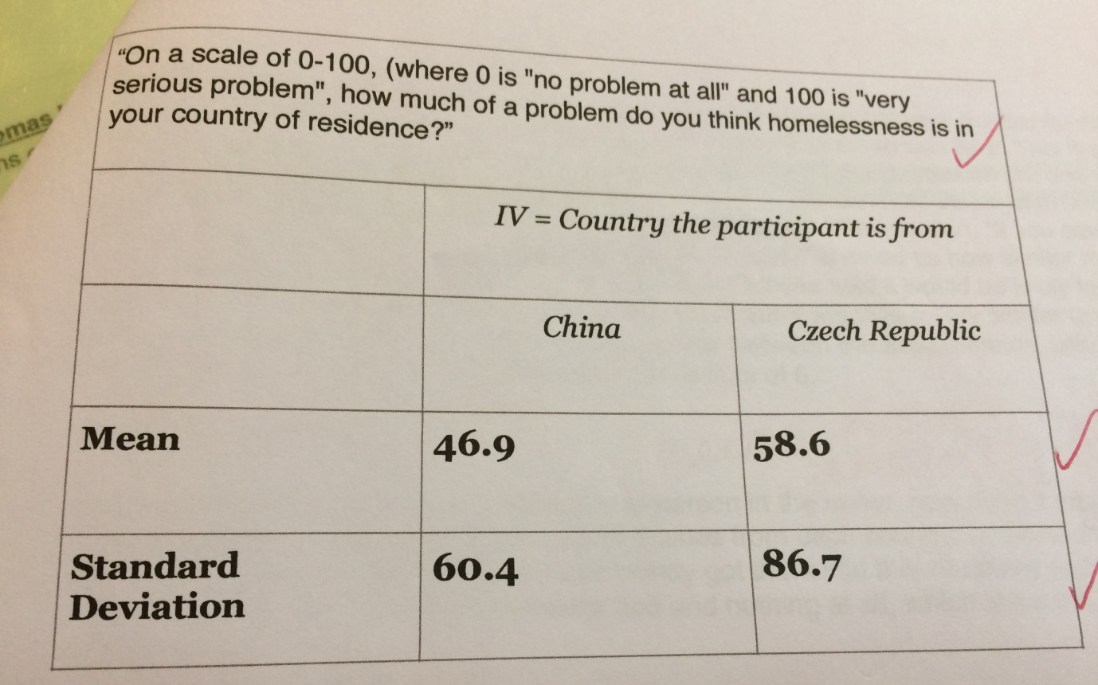

- Explain why did Amy chose to calculate the standard deviation? (2)
- Explain what Amy can conclude by looking her standard deviations (2)

