Operant Conditioning Assessment Questions
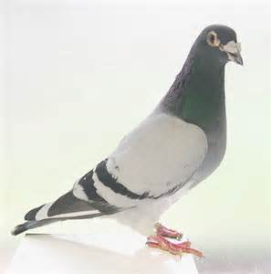
- Describe what is meant by each of the following with reference to examples from psychological research such as Skinner’s work with rats and pigeons:

  - positive reinforcement
  - negative reinforcement
  - positive punishment
  - negative punishment

- Describe what is meant by the following terms with reference to examples from real life:

  - primary reinforcement
  - secondary reinforcement

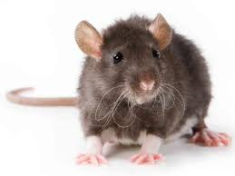
- Describe what is meant by the following terms which are all linked to reinforcement schedules. In each case, give an example from real life:

  - Continuous reinforcement
  - Fixed ratio
  - Variable ratio
  - Fixed interval
  - Variable interval

- Explain ONE reason why Skinner’s experiments on rats and pigeons are considered to be scientific? (3)

- Evaluate Skinner’s research into operant conditioning with reference to the research methods that he used (5)

- Skinner chose to work with non-human animals such as rats and pigeons. Explain why some psychologists use animals in their research (3)

- Give one strength and one weakness of using non-human animals in research into learning (2+2)

- Describe operant conditioning as a theory of learning (5)

- Evaluate operant conditioning as a theory of learning (6)

- Evaluate operant conditioning as a theory of learning (8)

- Match/colour code the psychologists with their associated terms/ideas

Food pellet | Pavlov
Law of Effect | Pavlov
Little Albert | Pavlov
Cannula | Pavlov
Santa Claus mask | Thorndike
Reinforcement schedules | Thorndike
Spontaneous recovery | Thorndike
Pigeons pecking discs | Thorndike
Conditioning of fear responses | Watson
Stamped in/out | Watson
Puzzle box | Watson
Reflexes | Watson
Salivation in dogs | Skinner
Smashing together of iron bars | Skinner
Fish | Skinner
Fixed ratio | Skinner

12. Compare the work of Pavlov on classical and Skinner on operant conditioning (4)

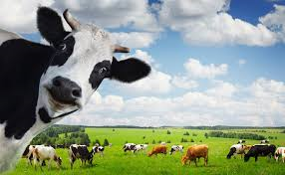
13. Classical and operant conditioning have been sued to train animals in many situations including for entertainment and in advertising. These techniques have also been used in farming. Read up from p. 222 on Vaughn et al (2014). Remember if theories can be used usefully in society, this is a strength of the theory and can be used in your evaluation.

    - Why do farmers need to train the cows in where to urinate and defecate? What effects can urine and faeces have on the environment?
    - Explain how electric cow trainers (cattle prods) have been used to try and teach the animals where to eliminate (urinate/defecate).

Part 1: Classical conditioning:
    - What is a diuretic and why did Vaughn this drug with the cows?
    - Why is this study deemed to be ethical (think! cost/benefit analysis)
    - Draw a sketch of the cows in the experimental and control group to remind you what happened in the study; write the key details of the procedure onto your sketch.
    - Why were the control group cows injected with saline?
    - Explain what the researchers were attempting to train the cows to do using the diuretic (UCS) and the stall (NS).

Part 2: Operant conditioning:
    - Why was the calves milk allowance cut/blocked?

    - Draw a sketch to illustrate what happened for each of the calves (experimental and control) regarding the rewards and punishments; remember this is not a study in detail you just need a rough working knowledge of the study so that you can use it as evaluation or an example if you want to.

    - Your textbook gives you some data reflecting the results of experiment one on classical conditioning as a way of getting cows to urinate in the correct place. It seems that classical conditioning did not work very well….the next section is fictional and is to help you to practice your maths for psychology skills…

Farmer Pat decided to replicate Vaughn’s study and see whether she could get her cows to wee in the correct place. The IV is whether the calves have undergone classical conditioning trials or not and the DV is the number of wees in the correct places.

- Write a directional hypothesis for Farmer Pat (2)

The table shows her data:

Treatment condition |  |  | Control condition
Calf no. | Training day | Test day | Calf no. | Training day | Test day
1 | 4 | 2 | 7 | 6 | 8
2 | 8 | 7 | 8 | 8 | 9
3 | 12 | 6 | 9 | 10 | 9
4 | 10 | 12 | 10 | 3 | 5
5 | 9 | 7 | 11 | 5 | 3
6 | 3 | 5 | 12 | 8 | 7
Mean |  |  | Mean
Standard deviation |  |  | Standard deviation

- Calculate the mean and standard deviation for each condition to two decimal places (8)
- Why is the mean a suitable measure of central tendency for this data?
- Draw a bar chart to compare the means for the experimental and control conditions (give suitable title and label both axes in full)
- What can you conclude from the results of Farmer Pat’s replication in comparison to Vaughn’s original data?
- What statistical test should Farmer Pat use on her data?
- Carry out the appropriate stats test on this data set comparing the amount of urination on the test day for the experimental and control calves.
- Using your critical values table…should Farmer Pat accept or reject her hypothesis and why (3)

- Overall Vaughn’s study seems to have shown that classical conditioning was not very successful, what reason are given for this?
- Operant conditioning was successful and the experimental calves did more wees in the correct place following the trials than the control calves and Vaughn also found that some calves were trained more successfully than others. What factors do they suggest may have impacted on the ability to train the cows? How would you work out which individual differences are most important in training cows?

