Paper 1 Essays
SOCIAL:
Psychologists have to abide by ethical codes of conduct, which help protect participants basic rights whilst ensuring that studies of are benefit to society.
P: One strength of these codes of conduct is that they remind psychologists think about alternative ways in which a study could be conducted.
E: For example Burger (2009) came up with a range of ethical safeguards such as ‘the 150V Solution’ in order to recreate Milgram’s study.
T: This was an important safeguard which meant participants did not suffer much as the shocks were relatively low, yet it still allowed Burger to estimate how obedient people might be today, but in an ethical way.
Fully informed consent is an important ethical consideration and should be obtained where ever possible, as when information is withheld this can increase the chance of psychological harm.
One problem with gaining fully informed consent is it can jeopardise the validity of the study.
For example, if Milgram’s participants had known that the shocks were not real and that he was studying obedience, not memory, the results would have been meaningless.
This shows that decisions about how much information can ethically be withheld may not be straightforward; had Milgram’s participants known the level of distress to which they were about to be subjected, many of them may not have wished to take part.
Participants should also be told of their ‘right to withdraw’ at the beginning of any social psychology study and reminded of this right throughout the procedure.
One problem with this is that in obedience research it is sometimes necessary to put participants under pressure to see whether they will obey orders even when they don’t want to.
For example, in Milgram’s study, Mr Williams issued four prods if the participants suggested that they wanted to withdraw and this was done in order to test the level of obedience.
This suggests that Milgram study violates modern ethical guidelines and demonstrates that historically social psychology has not had the best ethical track record.
Nowadays, ethics committees are used to decide whether a research study should go ahead and a cost/benefit analysis is used to weigh the costs to participants against the possible benefits of the research to society.
One strength of ethics committees is that they often include lay people in addition to experienced psychologists, making the decisions more objective and well rounded.
For example, in a study such as Sherif (1954), lay people might have objected to a summer camp where the camp counsellors deliberately tried to incite antagonism amongst the boys and thought more about the possible long term impact on the children.
This is important because if the only people involved in ethical decision-making are psychologists then the decision making may be biased, allowing research that may well be interesting to go ahead despite costs to participants that may only be apparent to people are more removed from research
In conclusion, while some of the more modern studies have been come up with careful safeguards to protect participants from harm, some of the older studies showed little concern for the long term impact on the participants and it is doubtful whether the long-term benefits to society have truly outweighed the costs to these individuals.

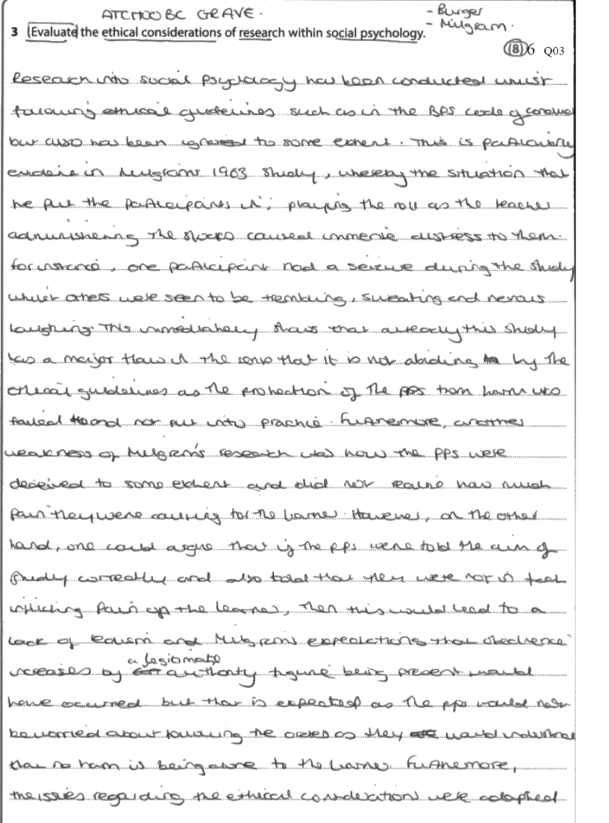

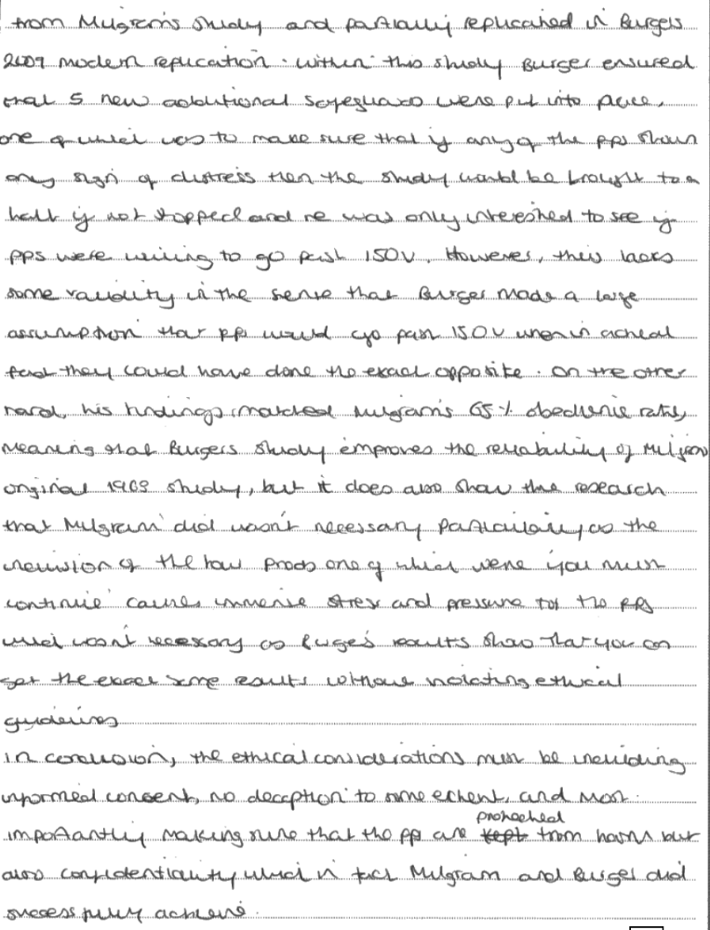

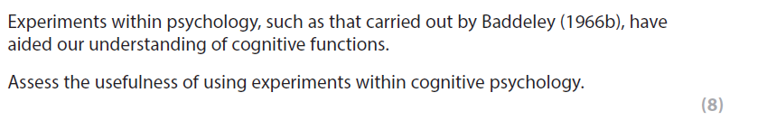
AO1:

AO3 chain:

AO1:

AO3 chain:

AO1:

AO3 chain:

AO1:

AO3 chain:

Conclusion

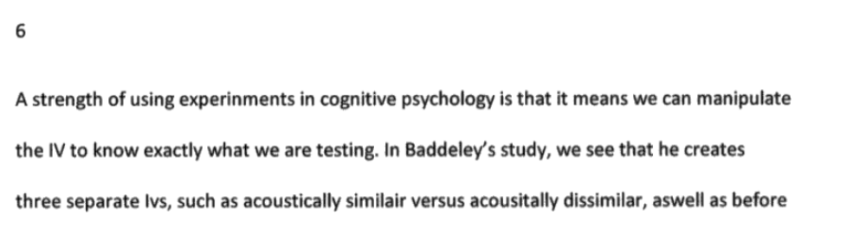
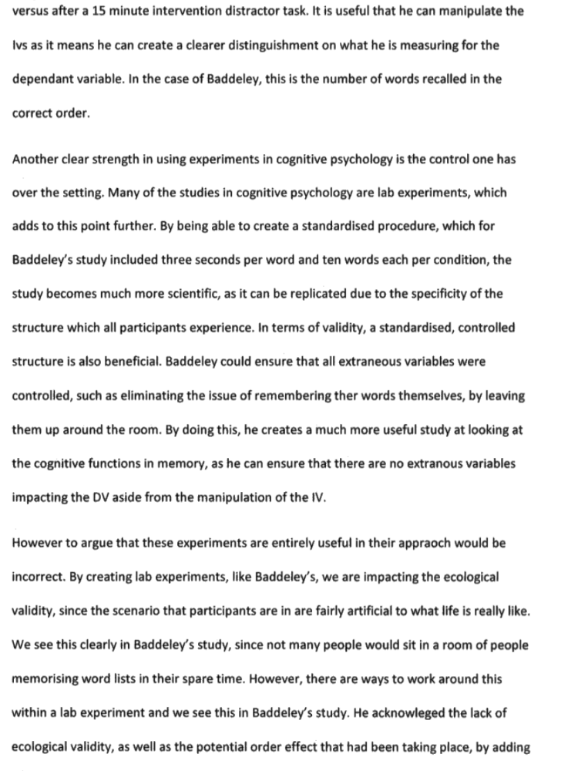
6/8

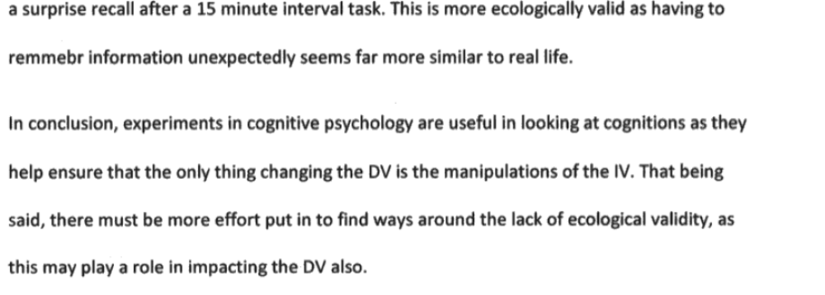

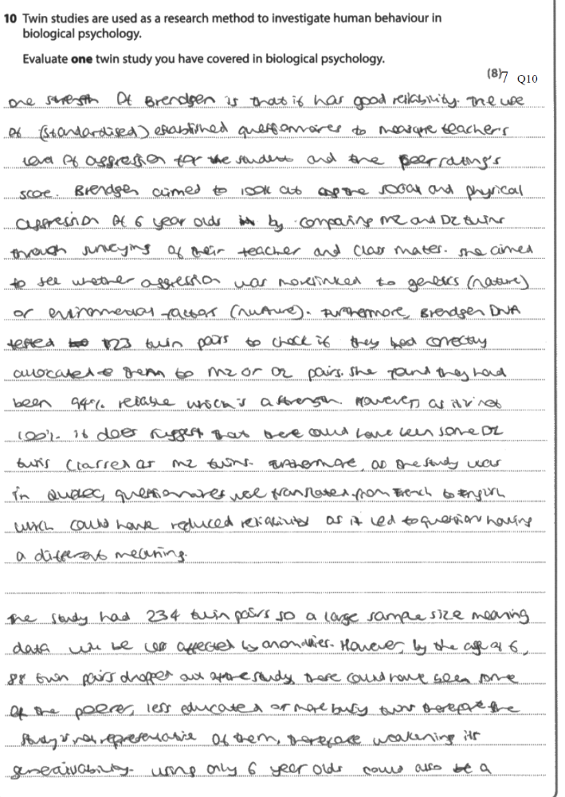

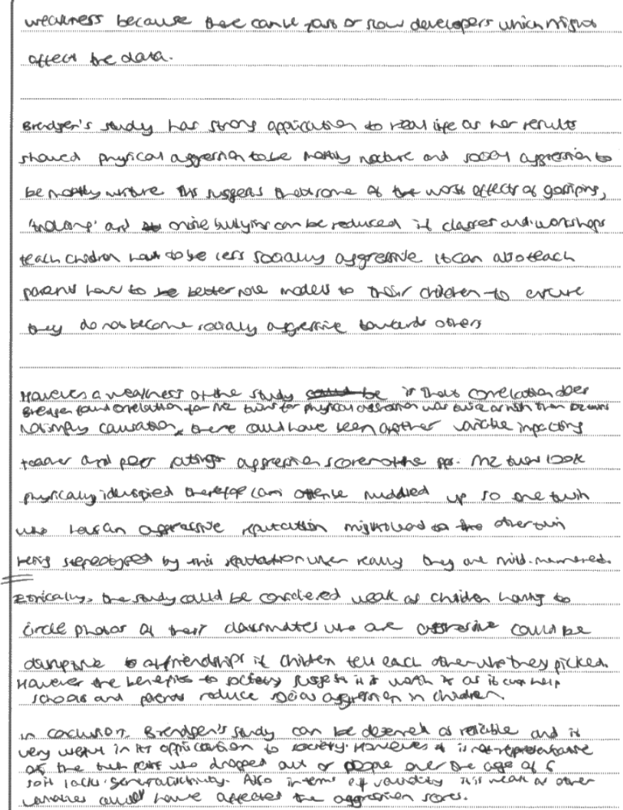

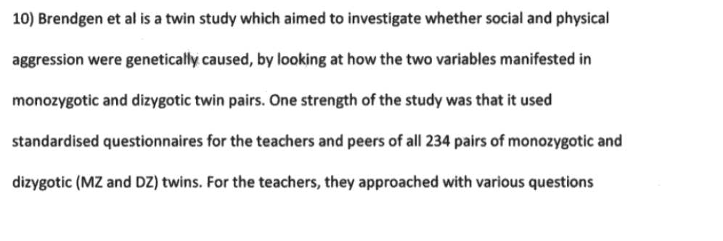
7/8

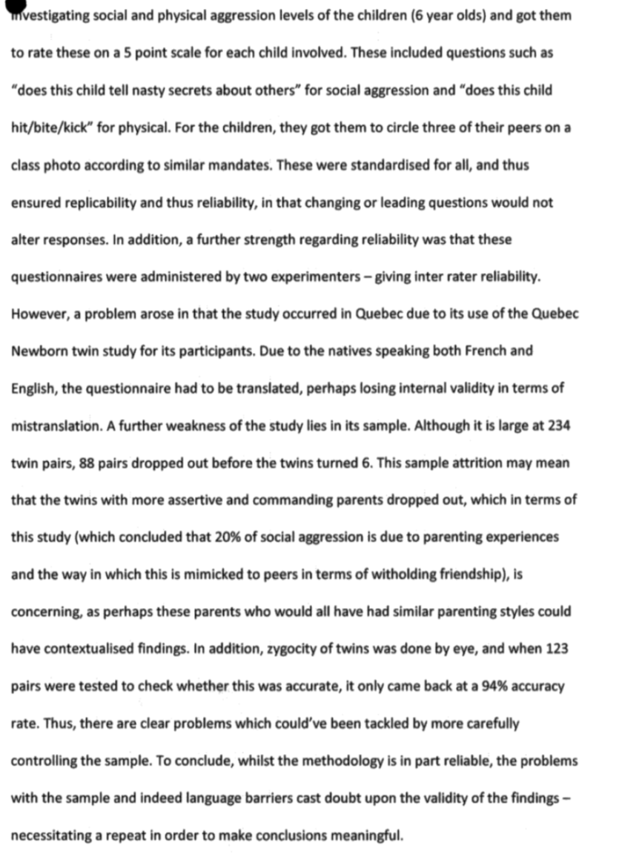

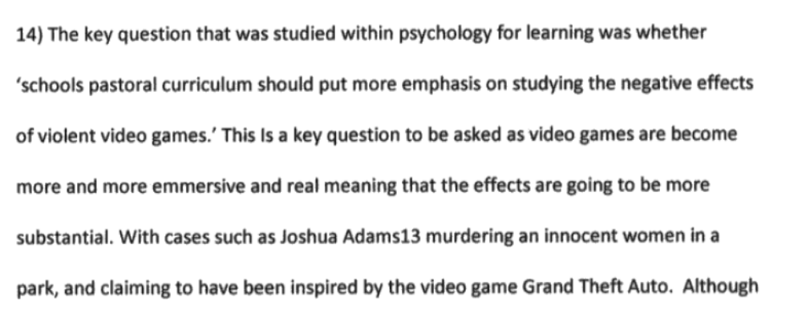
6/8
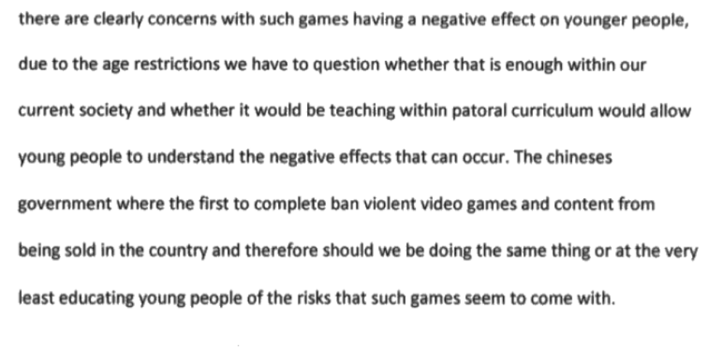
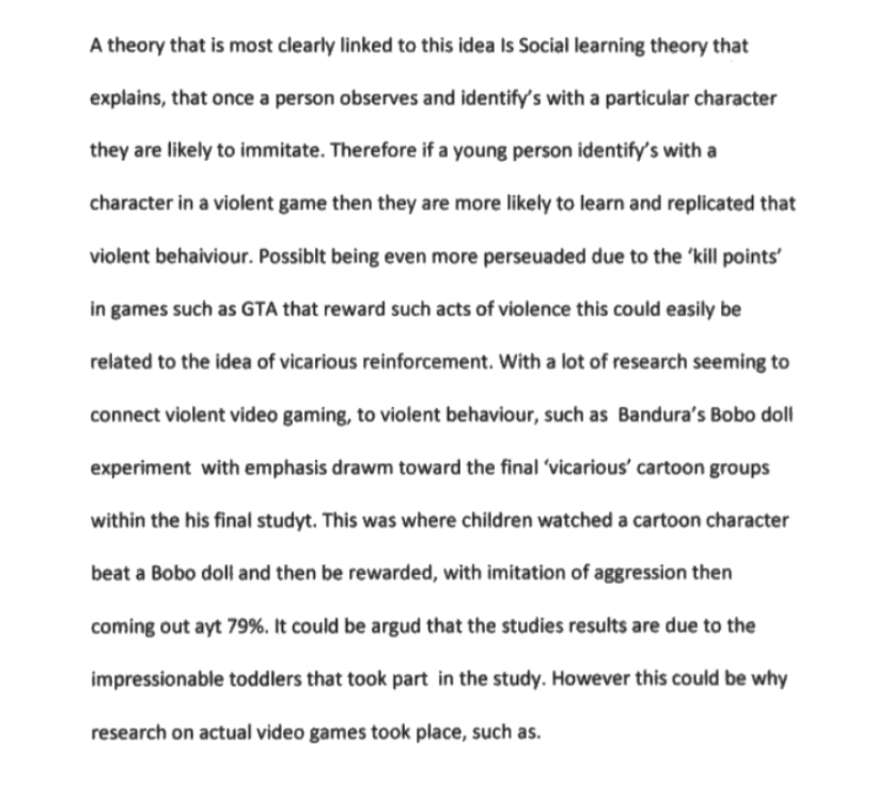
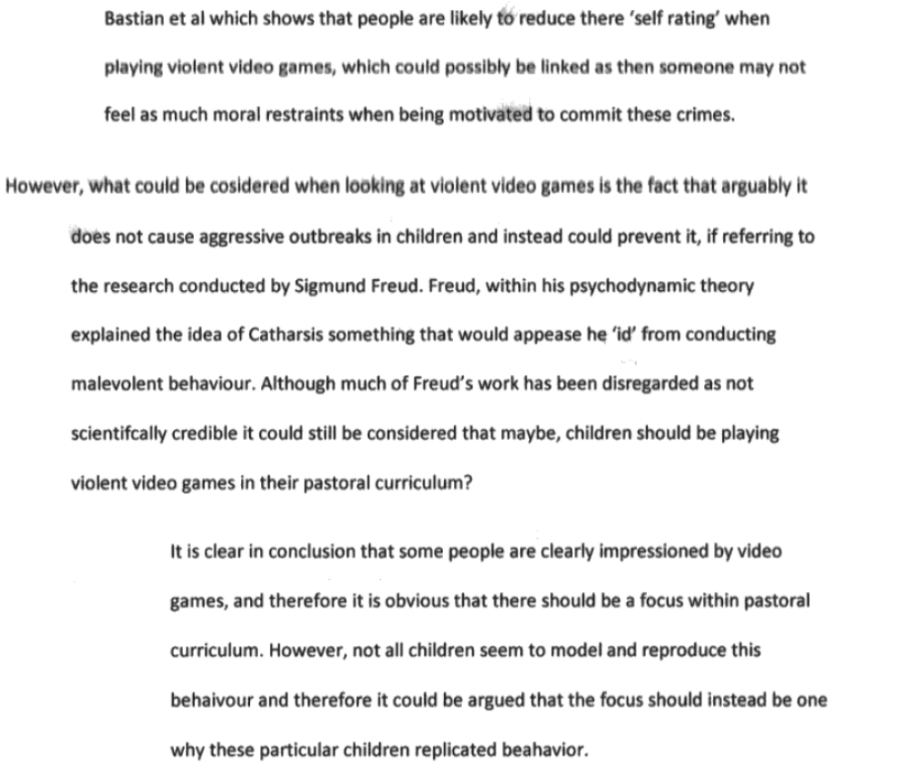

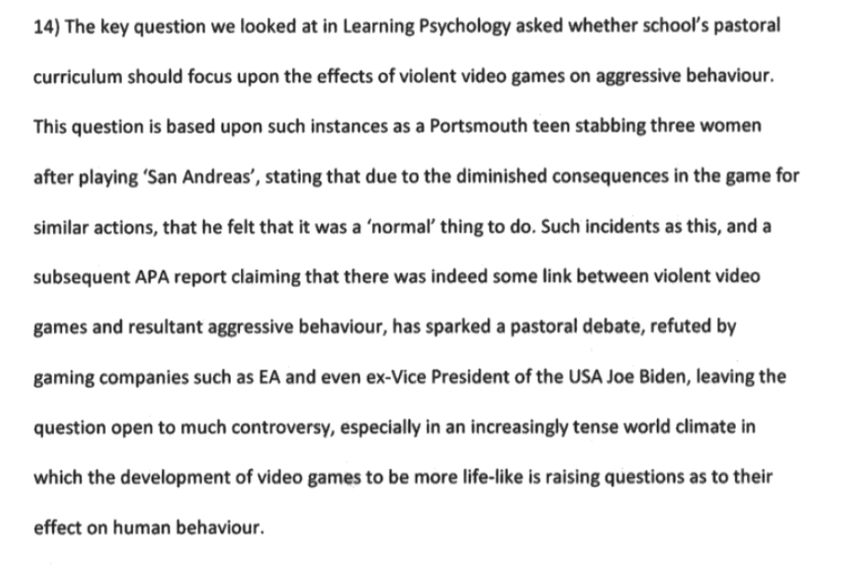
8/8

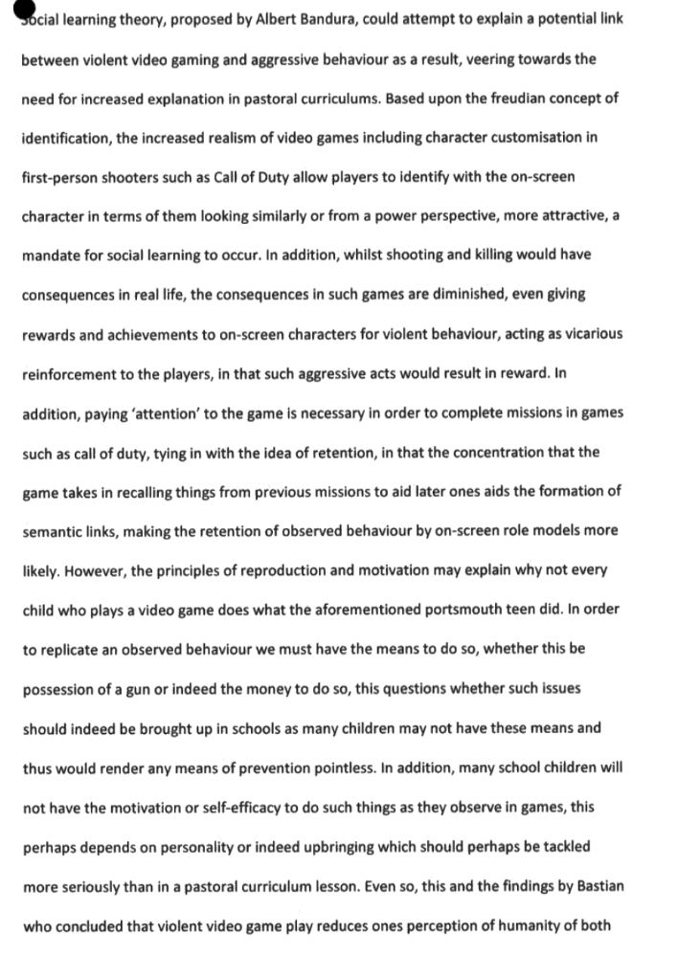
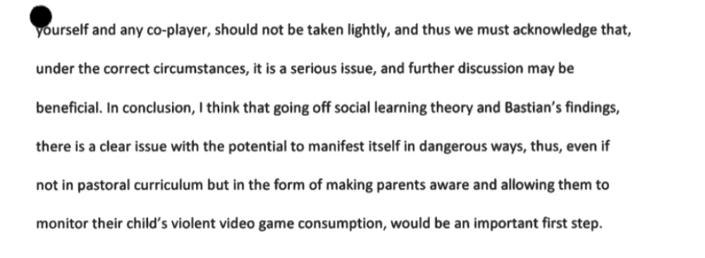
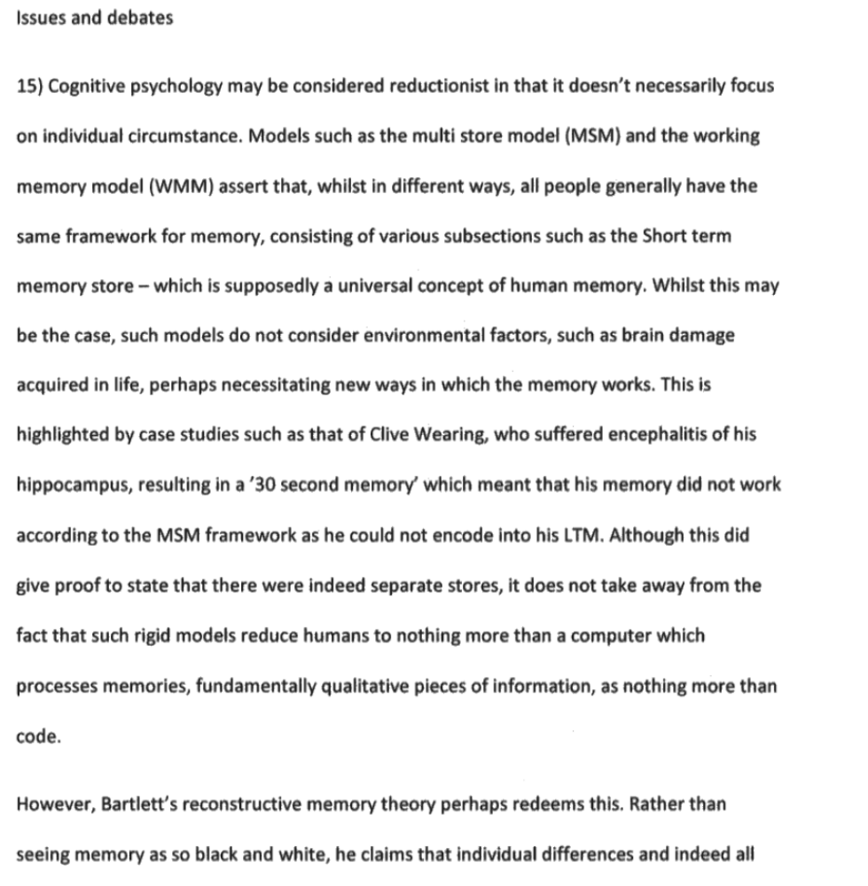
6/8
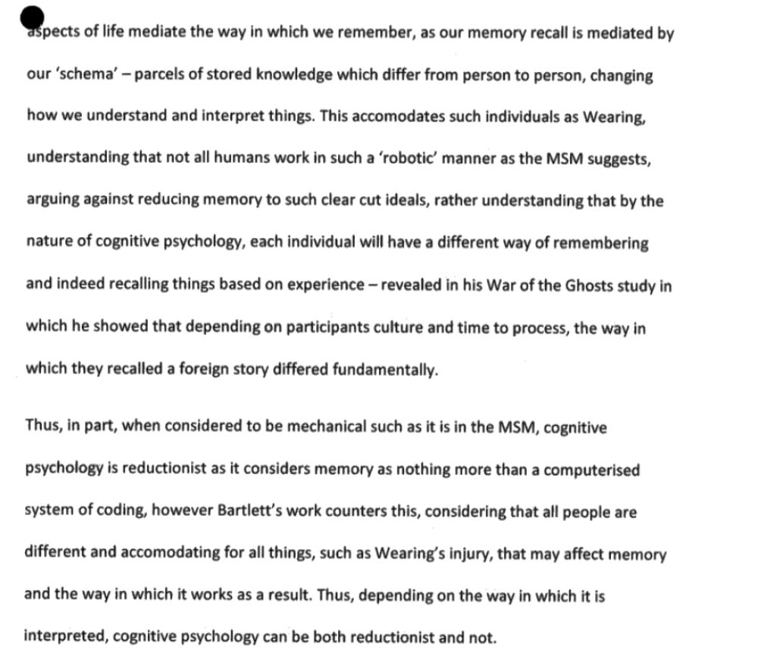
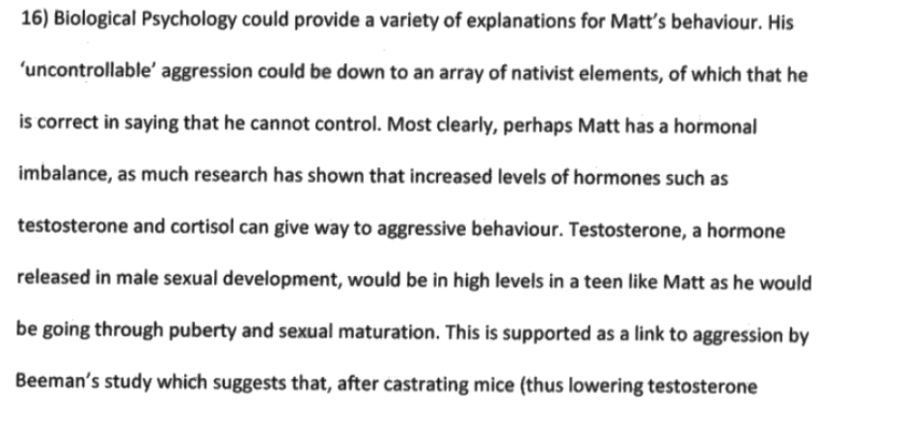
12/12

