Scarlett may also have issues with SEROTONIN

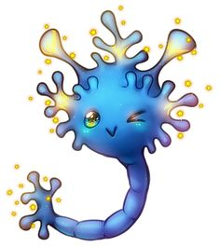
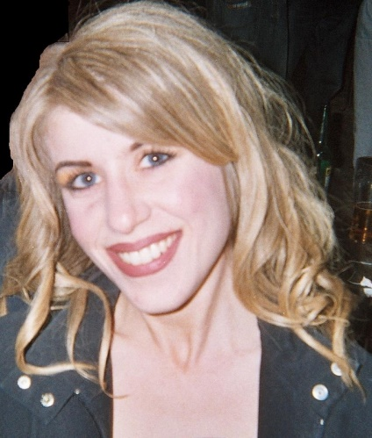
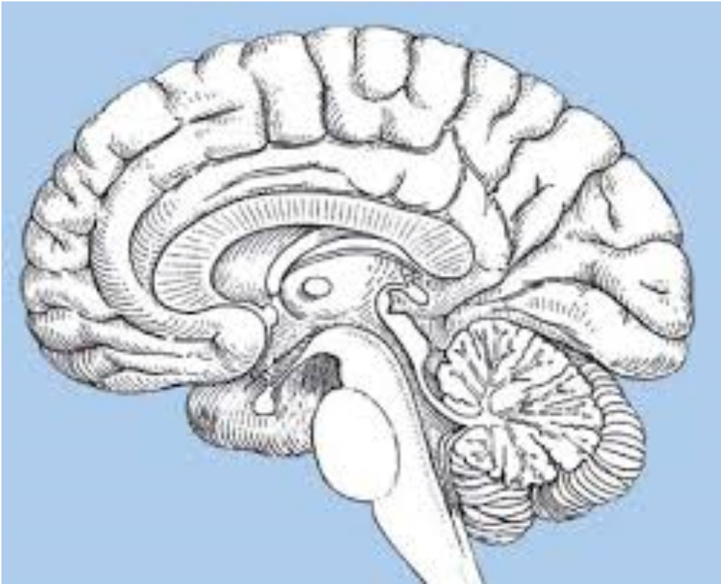
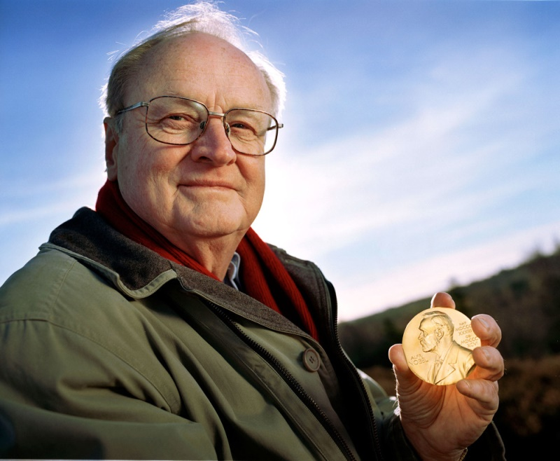

Hi, we are SEROTONIN and there are also a lot of us here! It’s probably our fault all that dopamine turned up as we invited them!

Your job: What drugs could Scarlet take to control her symptoms and why?

This lady has schizophrenia; let’s see what’s going on in her brain

