If the SGA doesn’t work, the doctor might try an FGA such as

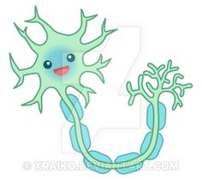





This is Chlorpromazine, (but you can call him Sir ;)
Sling your hook dopamine, you ain’t welcome here. Scarlett doesn’t want you and neither do I!
We

D2
Your job: What side effects might Scarlett suffer from if she takes chlorpromazine? What alternatives does she have?
THE MESO-LIMBIC PATHWAY
Where’s the party?
This lady has schizophrenia; let’s see what’s going on in her brain

