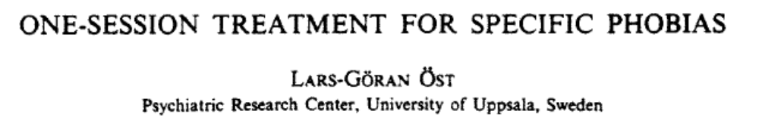
Data Response Question: Ost (1989)

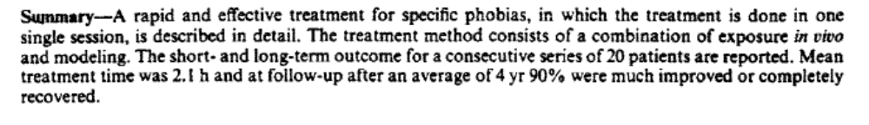

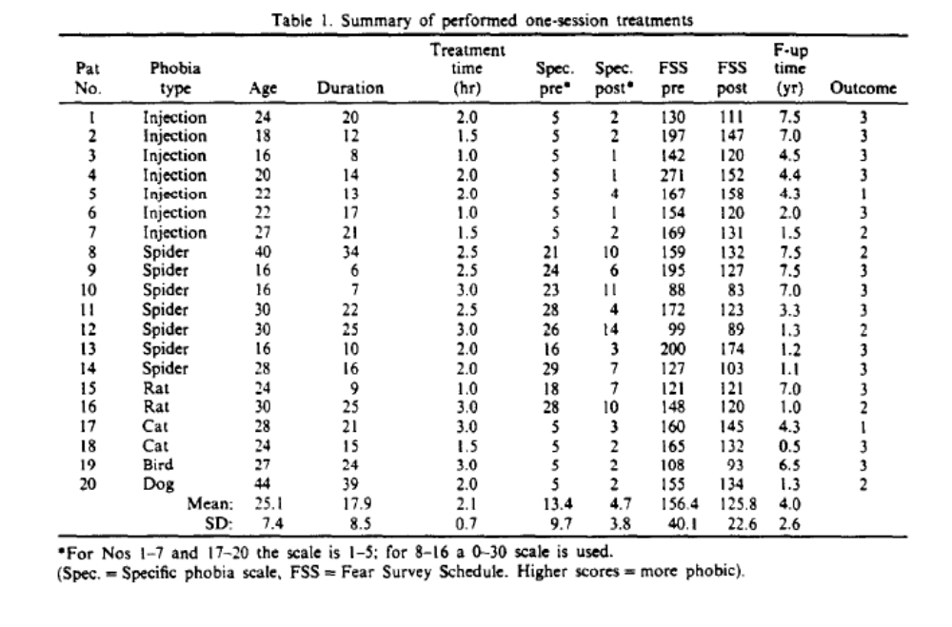
- Which was the modal category for phobia type?
- What was the mean average treatment time?
- Determine two conclusions that can be drawn from looking at the pre and post Fear Survey Schedule Scores (FSS).
- What was the range for the follow-up time (F-up time yrs)?
- What was the mode for outcome?

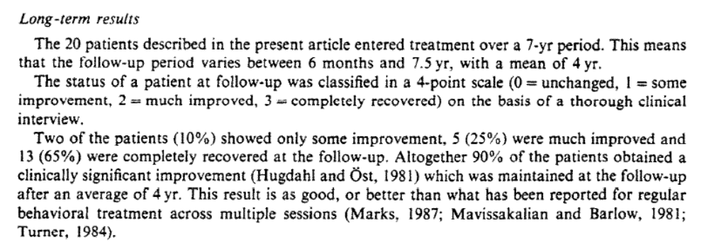
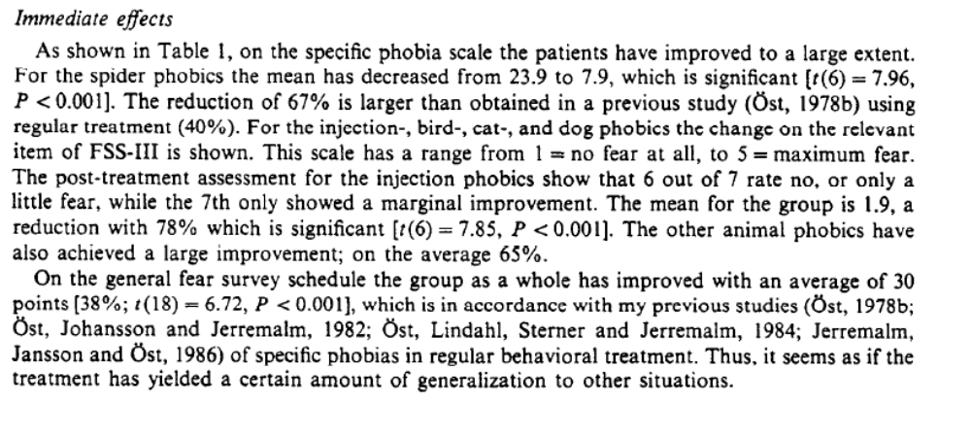

Complete the following:
One strength of flooding as a therapy for phobias is that it is supported by Ost (1989) who found that…

This is important because…


This said, flooding may not be suitable for everyone because…

