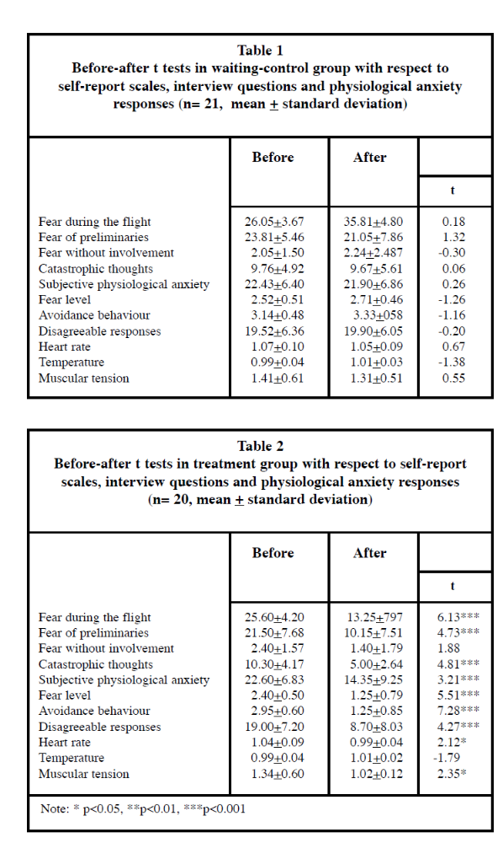
Capafons Findings in detail
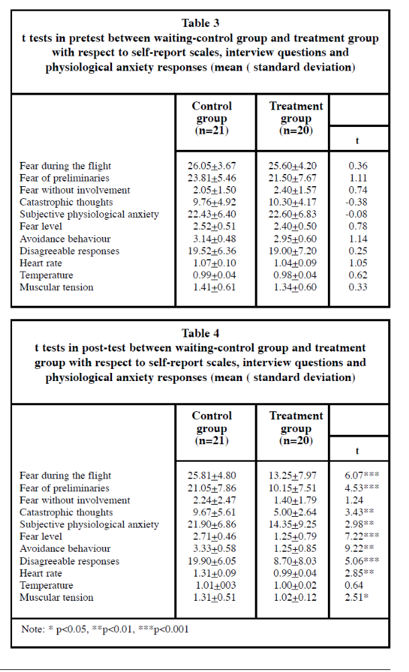
Task: With reference to the tables above, determine four conclusions that can be drawn about the effectiveness of SD for fear of flying. (8)
Only two post-treatment patients had similar scores to those of the non-treated patients, thus, only 10% of patients with a fear of flying do not undergo significant reduction of symptoms.
- Can you turn this finding into a strength and a weakness of SD?
Capafons also found that only one control group patient (less than 5%) presented a profile of scores similar to that of the treatment group, i.e. the passing of time alone was enough to bring about a reduction in symptoms.
- Can you turn this finding into a strength of SD?

