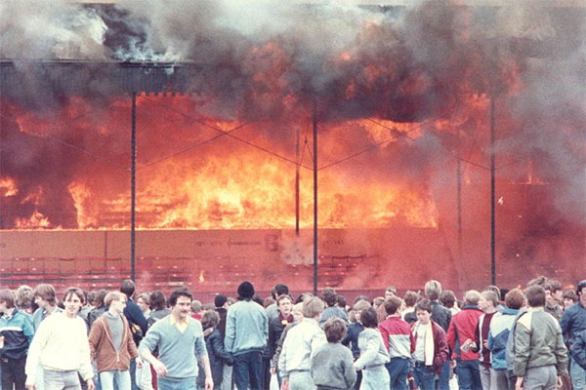
Everyone for themselves? A comparative study of crowd solidarity among emergency survivors
Drury et al (2009)
Aim:
- To investigate the role of shared identity (high versus low identification) in terms of the behaviour of crowds in mass emergencies
- Hypotheses:
  - high identification would result in greater expressions of solidarity and reduction in panic behaviour
  - sharing the experience itself could leads to feelings of identification within affected individuals.
Sample:
- 21 survivors (11 male and 10 female) of 11 emergencies
- volunteer sample recruited by placing advertisements in UK national newspapers for people who had been involved in emergencies such as fires in public places, sinking ships, and bomb attacks
- Following initial recruitment, snowballing was used to gather more participants
- People who had been involved in the Hillsborough, UK, football stadium crush in 1989 and the Fatboy Slim beach party in Brighton, UK, in 2002 were also contacted
- offered £10; many donated to charity
- Emergencies included the sinking of two cruise ships, emergency evacuation of tower blocks following 911, a train accident, etc.
Research Method:
- Semi-structured Interviews lasting 45-90 minutes
- Pps chose where the interviews took place, e.g. home
- Interviewees was asked to set the scene, and then tell the story of the events they remembered. The interview schedule included the following issues
- Behaviour: ‘What did you do in response to these events? How quickly did people respond and begin to evacuate? Was evacuation easy/difficult? Why? What did others do? Did people co-operate/help each other out? Did anyone behave selfishly?’
- Thoughts/feelings: ‘What were you thinking/feeling as the incident progressed? Can you describe your emotions? How strong were these emotions? Did you feel in control of your actions/feelings? Do you think that anyone panicked? What did they do?’
- Identification: ‘How would you describe those in the evacuation with you? How did you feel towards them? Did you feel a sense of unity with each other?’
Analysing the qualitative data:
- interviews were fully transcribed, 157,332 words total, 7492 average per interview
- thematic coding in relation to the issues of interest
Operationalisation
- Shared identification was operationalised as feelings of ‘unity’ and ‘togetherness’ (felt by the survivor and/or perceived by the survivor amongst others in the crowd)
- Shared fate was operationalised as references to shared danger, including shared threat of death
- Solidaristic behaviours were operationalized as ‘helping’, e.g. lifting people up, moving objects to help others to escape, giving encouragement, sharing bottles of water, giving information and advice. Selfish behaviours were operationalised as barging or pushing others aside ignoring others in need, trying to step in ahead of others and ignoring pleas for help
- Orderliness was operationalized as references to order and calm, being in control of one’s emotions, ‘panic’ (collective and individual), adherence to everyday rules (norms), maintenance of social roles, and (dis)courtesy (references to dis/courtesy, politeness, saying please or thank you and other displays of manners, people offering that others go first, rudeness, and apologies)
How were the transcripts analysed?
- The size of a piece of coded text varied from a sentence to a multi-sentence chunk
- Sentences or chunks were coded according to the rule of thumb: assign the single most appropriate code in the scheme
- We coded for both the number of interviewees per theme and, where appropriate, the number of instances of behaviour per interviewee
Inter-rater reliability:
- To check for reliability, we trained an independent judge in use of the coding scheme; she and the lead researcher then separately coded a sample of the material. On 189 observations there were 152 agreements, 80% agreement.
- Small sample size meant that only descriptive quantitative analysis was applied

Findings:
Emergent themes | Example | Notes
lack of unity | “It wasn’t a group thing, it was a very individual lots of individuals together”  “ I felt like I was with my... five or six friends and that was it.. and it was like the others were the enemy” | Expressed by small minority
Some shared identification, for some people some of the time | “ in this moment you are very concentrated in yourself really because you have to get out of the place.. but of course you see that everybody is doing the same but in this moment, you are more like…so of course the sense of community and because we were all going out..from that..”
Strong sense of shared identity. | How would you describe those who were in the evacuation with you? Is there any phrase or word you would use to describe them?  “I guess I’d say mutually supportive. We were all strangers really, we were certainly surrounded by strangers but most of, I mean I’d got my kids by me, but most people were split up from anybody they knew, and yet there was this sort of camaraderie like you hear about in the war times and this sort of thing.. there, there was certainly a pulling together as opposed to a pulling apart” | 12/21 Pps
“ a sense of unity with strangers” | “I think everyone would accept that one had really gone beyond the definition of identifying the person as a supporter of football… at this point, they’re just human beings struggling, to be fair, I don’t think anyone saw Liverpool fans and Notts Forest fans. People stopped being supporters of a football team and were just people. (Hillsborough) | Sometimes a sense of unity was present in the crowd before the emergency, e.g. football stampedes and Fat boy Sim party  For most ‘sense of unity’ increased, in strength and/or inclusiveness, following onset of the emergency
Shared threat |  | 92% of those in the high identification group endorsed the statement of a shared sense of danger compared with 67% in the low identification group.
Helpfulness | “As soon as I could get my arms out I was helping people and pushing them up, yeah, absolutely it was.. yeah it was only you felt that ‘cos I mean it’s only when you look back you just feel ‘oh I could have done that’, I mean you look back, I mean everyone did help each other and I don’t think there was anyone that.. could really look back and say I didn’t do anything to help anybody ( Jupiter 3)” | far more common in the high ID group compared with low.
Helpfulness | “The behaviour of many people in that crowd and simply trying to help their fellow supporters was heroic in some cases. So I don’t think in my view there was any question that there was an organic sense of unity of crowd behaviour. It was clearly the case, you know, it was clearly the case that people were trying to get people who were seriously injured out of that crowd, it was seriously a case of trying to get people to hospital, get them to safety.. I just wish I’d been able to prevail on a few more people not to put themselves in danger. (Hillsborough 3) | far more common in the high ID group compared with low.
Disregard for personal safety
Powerful sense of togetherness

Order and calm | Was it quite orderly waiting in this queue?  J1: It was very orderly very orderly noisy but very orderly and people calling out and and this teacher very calmly saying ‘come on, just keep going get going get going’ | more frequent for Hi than lo ID survivors, e.g. queuing.
‘Mass panic’ | “People were trying to barge past me, although that was really selfish. No-one was letting me go first. There was no courteousness at all”  (Fatboy Slim 3) | more common in low than high ID.
discourtesy |  | more common in low than high ID.

