Thinking and Decision-Making
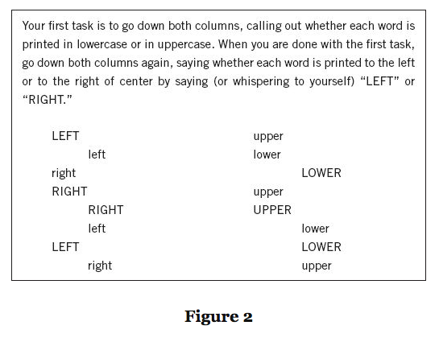
System 1 and 2 Thinking

