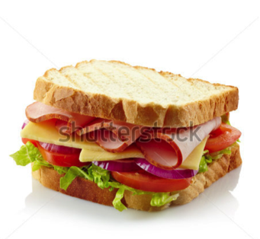<caption> Great evaluation is just like making a tasty sandwich, start with a slice of bread, ‘one strength of …’, slap on some of you favourite fillings, ‘For example, a study by …’ and then pop on a final slice of bread to hold it all together, ‘this shows that…’.

